Step of to find missing data

### 1 Install Required Packages

install.packages(c("tidyverse", "mice", "DMwR2", "recommenderlab", "ggplot2", "VIM"))

library(tidyverse)

library(mice) # For MICE imputation

library(DMwR2) # For k-NN imputation

library(ggplot2) # For visualization

library(VIM) # For missing data patterns

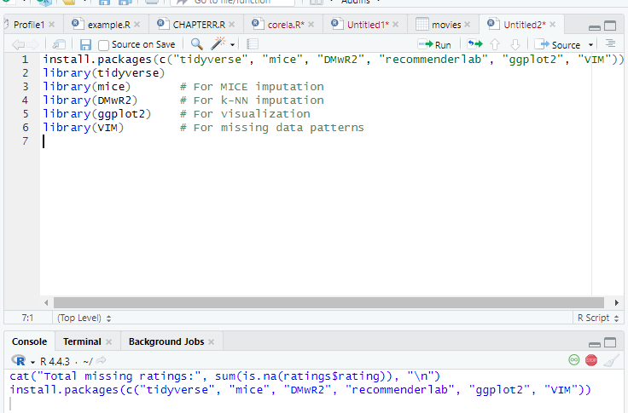

### 2 Load MovieLens 100k Dataset

# Download and load the dataset (if not already available)

download.file("http://files.grouplens.org/datasets/movielens/ml-100k.zip", "ml-100k.zip")

unzip("ml-100k.zip")

# Load ratings data

ratings <- read.table("ml-100k/u.data",

header = FALSE,

sep = "\t",

col.names = c("userId", "movieId", "rating", "timestamp"))

# Load movie information

movies <- read.table("ml-100k/u.item",

header = FALSE,

sep = "|",

quote = "",

col.names = c("movieId", "title", "releaseDate", "videoReleaseDate",

"IMDbURL", "unknown", "Action", "Adventure", "Animation",

"Children", "Comedy", "Crime", "Documentary", "Drama", "Fantasy",

"FilmNoir", "Horror", "Musical", "Mystery", "Romance", "SciFi",

"Thriller", "War", "Western"))

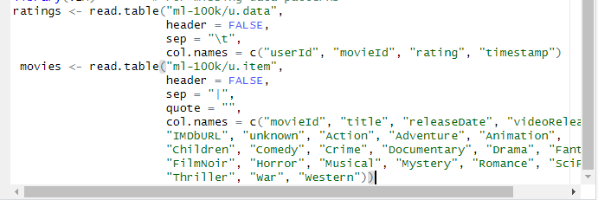

### 3 After the Check for Missing Values

### cat("Missing values in ratings:", sum(is.na(ratings)), "\n")

### cat("Missing values in movies:", sum(is.na(movies)), "\n")

### 

### 4 over all workspace of the r studio

### 

### Conculisoin

### In movieslenes dataset there no missing value in rating and movie dataset so No imputation needed; use sparsity-aware algorithms.

* **MovieLens 100k has no**NA**values**, but it **is sparse** (most user-movie pairs unrated).
* To analyze "missingness" (sparsity):
  + Use fill = NA in spread() to force NAs for unobserved pairs.
  + Visualize with VIM::aggr() or a heatmap.
  + For recommendation systems, focus on **sparsity handling** (e.g., collaborative filtering) rather than imputation.

### ****Final Answer****

**No, you don’t need imputation** for the MovieLens 100k dataset. Focus on recommendation algorithms that handle sparsity natively (e.g., UBCF, matrix factorization). Imputation is only useful if you artificially create NAs or switch to a method requiring dense data.

**Understanding Sparsity**

* **Definition:** A dataset is sparse if a large proportion of the potential user-item interactions (ratings) are missing.
* **Why it Matters:**
  + **Computational Efficiency:** Dense matrices (user x movie) become enormous and inefficient to store and process.
  + **Algorithm Performance:** Many standard algorithms (like basic correlation or some machine learning models) struggle with high amounts of missing data. They might fail or produce poor results.
  + **Cold Start Problem:** New users or new movies have few or no ratings, making it hard to generate recommendations for them (related to sparsity).

**Common Sparsity Handling Techniques in R**

1. **Representing Data Efficiently:** Use sparse matrix formats.
2. **Calculating Sparsity:** Quantify how sparse the data is.
3. **Filtering:** Remove users or items with very few ratings (use with caution).
4. **Using Algorithms Designed for Sparsity:** Employ techniques like matrix factorization (e.g., SVD, NMF) or neighborhood-based methods (UBCF, IBCF) that inherently handle sparse data.
5. **Dimensionality Reduction:** Techniques like PCA or SVD can capture latent factors even from sparse data.
6. **Imputation (Less Common for Preprocessing, More for Modeling):** Filling in missing values. Often done implicitly by recommendation algorithms (like matrix factorization) rather than as a separate preprocessing step. Simple mean imputation is usually not recommended for recommendation tasks as it distorts the data.

**Explanation of the Code:**

1. **Libraries:** Load necessary packages.
2. **Data:** Simulates or loads user-item rating data into a data frame (ratings_df).
3. **Calculate Sparsity:** Computes and prints the percentage of missing ratings in the potential user-item interaction space. This gives you a measure of how sparse your data is.
4. **Sparse Matrix Representation:**
   * Converts the data frame into a sparseMatrix using the Matrix package. This is crucial for memory efficiency with large datasets.
   * It uses the row index (i), column index (j), and rating value (x) to define the matrix.
   * dimnames are added for readability.
5. **Filtering:**
   * Demonstrates how to filter the *original data frame* to remove users and movies that have fewer than a specified number of ratings (min_ratings_per_user, min_ratings_per_movie).
   * **Important:** This step *reduces* the dataset size and changes the sparsity calculation. It's a trade-off: you get a denser matrix (within the remaining users/items) which might help some algorithms, but you lose potentially valuable information from less active users or niche items.
   * The code recalculates the sparsity *after* filtering to show the effect.
6. **Using recommenderlab:**
   * Shows how to convert the sparseMatrix into the realRatingMatrix format required by the recommenderlab package.
   * This package contains algorithms (like User-Based Collaborative Filtering - UBCF, Item-Based Collaborative Filtering - IBCF, SVD, ALS-WR) specifically designed to work effectively with these sparse rating matrices. This is often the *best* way to "handle" sparsity – use tools built for it.
   * Includes a visualization of the sparsity pattern using image().
7. **Imputation (Conceptual):**
   * Briefly touches upon imputation (filling missing values).
   * **Crucially, it highlights that simple mean imputation is generally a poor strategy for recommendation systems.**
   * Advanced techniques like matrix factorization perform implicit imputation as part of the model building process by predicting the missing ratings based on learned latent factors. Performing simple imputation *before* these methods can actually harm their performance. The commented-out code shows how you *could* do it, but it's primarily for illustration and generally discouraged for this context.

